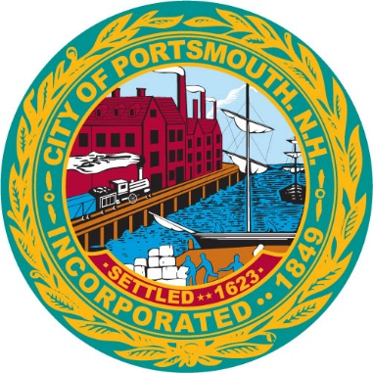

Arts and Culture Commission
Notice of Quorum

Please be advised that the Arts and Culture Commission may have a quorum present on Wednesday February 7, 2023, from 5:30 pm until 7:00 pm. This meeting is scheduled to be held at The Music Hall Lobby in Portsmouth.

Kelli L. Barnaby, MMC/CNHMC
Portsmouth City Clerk

